

CSA10 - Software Engineering
Lab Experiments
NAME: ROSE MYSTICA.J
REG NO: 192421410

1 | Create a Kanban Board to Visualize the Tasks.  - Create Columns for To Do, In-Progress and Done.  - Add at least 5 Sample Tasks  - Move the Tasks across the Columns to Simulate the Workflow. | Jira or Trello

Using Jira
PROCEDURE:
Step 1: Login
- Go to jira.atlassian.com
- Login to Jira account.
Step 2: Create Project
- Click Create Project
- Select Kanban project
- Name: Kanban Workflow Project
- Click Create.
Step 3: Verify Columns
Ensure board has:
- To Do
- In Progress
- Done
(If not, configure columns in board settings.)
Step 4: Create Issues (Tasks)
Click Create Issue and add:
- Collect project requirements
- Design UI mockups
- Develop login module
- Test application
- Prepare final report
Step 5: Move Issues
Drag issues:
- First two → In Progress
- Then move one → Done
Step 6: Final Simulation
- Design UI mockups → Done
- Develop login module → In Progress
SCREENSHOT:
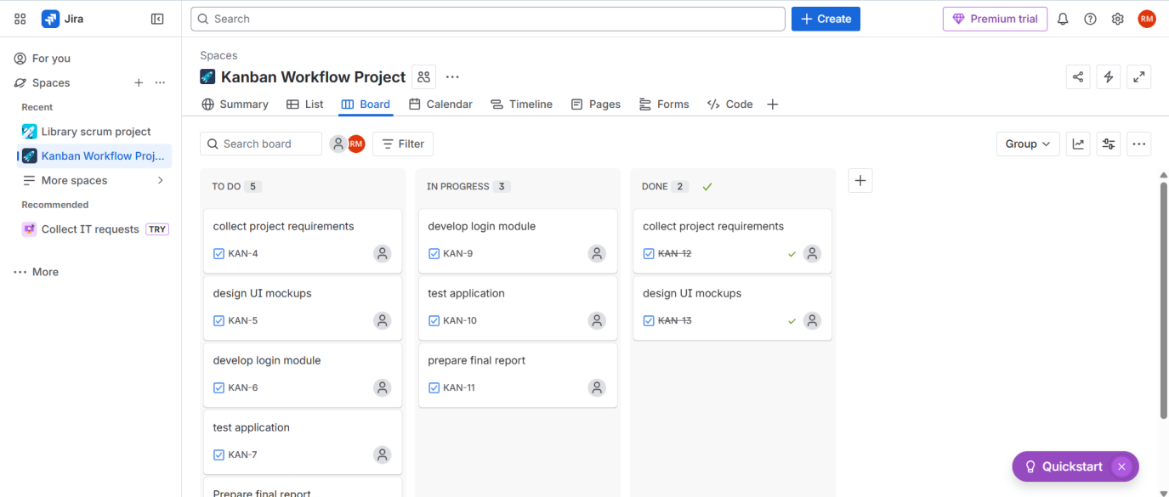

Using Trello
PROCEDURE:
Step 1: Login
- Open browser → go to trello.com
- Login using Google / email account.
Step 2: Create a Board
- Click Create → Create Board
- Name it: Kanban Workflow Board
- Click Create.
Step 3: Create Columns (Lists)
Rename default lists as:
- To Do
- In-Progress
- Done
(Delete extra lists if any.)
Step 4: Add Sample Tasks
Under To Do, add these 5 cards:
- Collect project requirements
- Design UI mockups
- Develop login module
- Test application
- Prepare final report
Step 5: Move Tasks to In-Progress
Drag and drop:
- Collect project requirements
- Design UI mockups
➡ from To Do to In-Progress
Step 6: Move Completed Tasks to Done
After completion:
Drag Collect project requirements → to Done
Step 7: Continue Workflow Simulation
- Move Design UI mockups → Done
- Move Develop login module → In-Progress

SCREENSHOT:
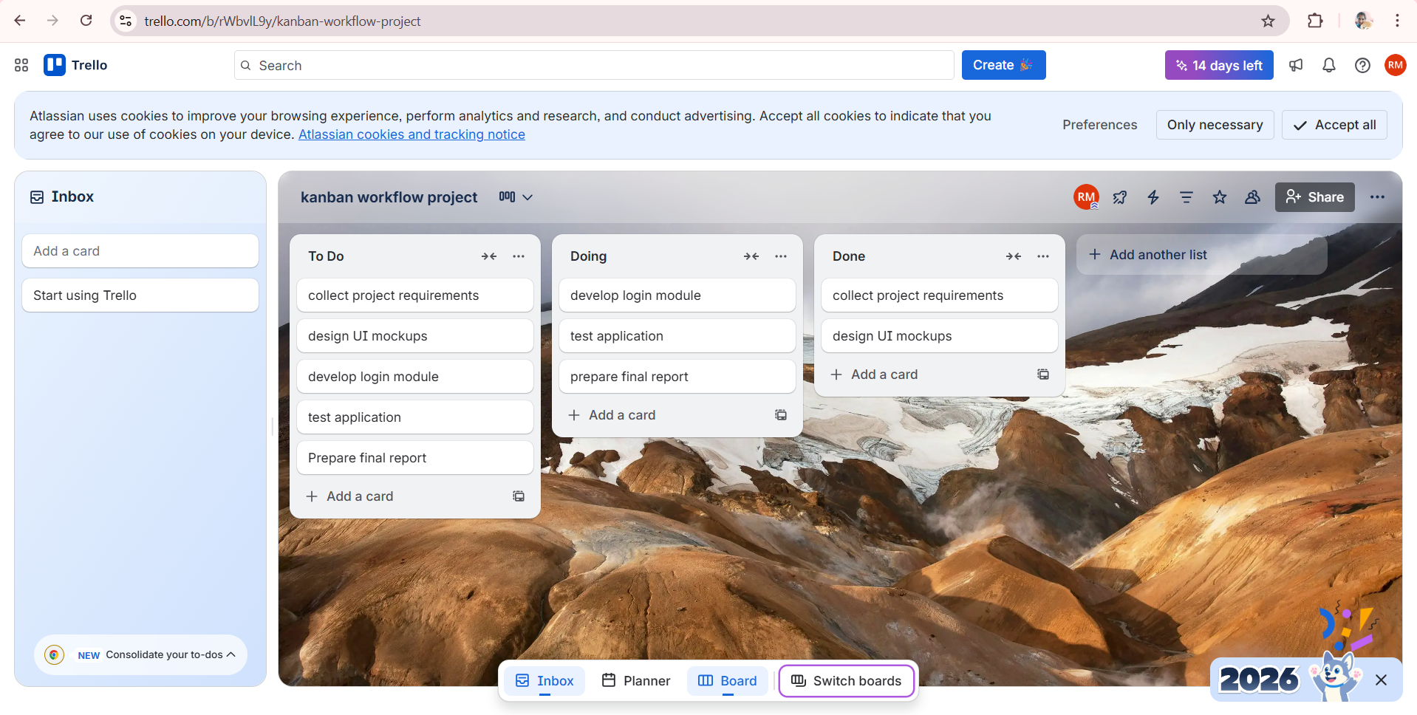

2 | Sketch a Simple Prototype of a Bus Ticket Booking System using Figma Tool | Figma | CO1

PROCEDURE:
Step 1: Login to Figma
- Open browser → go to figma.com
- Click Login / Sign Up
- Login using Google or email.
Step 2: Create a New Design File
- Click New Design File
- Rename file as:
Bus Ticket Booking Prototype
Step 3: Create Frame (Mobile Screen)
- Click Frame Tool (F)
- Select device: Android / iPhone (375 × 812)
- This represents the mobile app screen.
Step 4: Design Home Screen
Add these UI elements:
Header
- Text: Bus Booking App
Input Fields
- From City
- To City
- Travel Date
Button
- Search Buses
Arrange neatly using rectangles and text.
Step 5: Design Bus List Screen
- Duplicate first frame (Ctrl + D)
- Add:
- Bus Name
- Time
- Price
- Book Now button
Create 2–3 sample bus listings.
Step 6: Design Seat Selection Screen
Duplicate frame again:
Add:
- Seat grid (rectangles as seats)
- Selected seat in different color
- Proceed to Payment button
Step 7: Design Payment Screen
Duplicate frame:
Add:
- Ticket summary
- Total price
- Payment method dropdown
- Pay Now button
Step 8: Create Confirmation Screen
Add:
- ✔ Booking Confirmed
- Ticket number
- Travel details
- Download Ticket button

Step 9: Create Prototype Links
- Click Prototype tab
- Search Buses → Bus List Screen
- Book Now → Seat Selection
- Proceed → Payment
- Pay Now → Confirmation

Step 10: Preview Prototype
- Click Play ▶ icon
- Test full booking flow.

Step 11: Save and Share
- Click Share
- Set permission to Anyone with link – View
- Copy link.

SCREENSHOT:
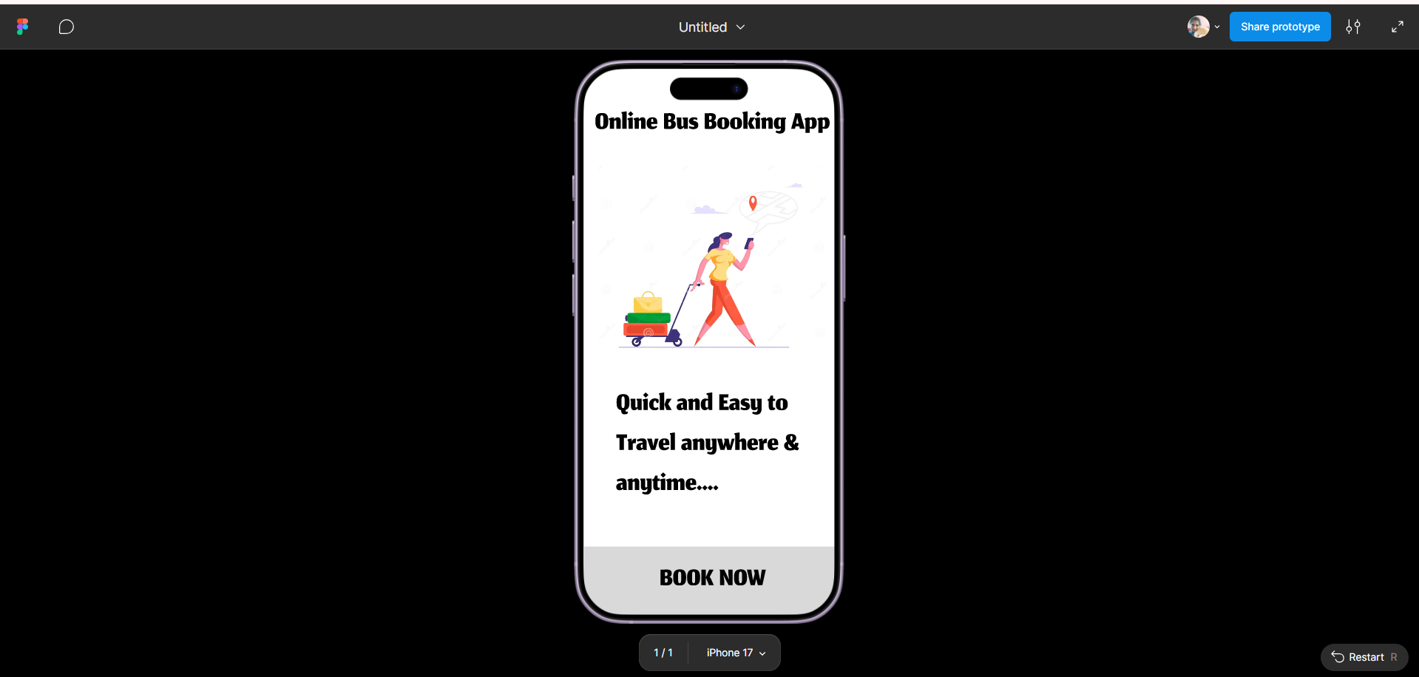

3 | The stakeholders have conflicting views on the user interface design for an E-Commerce mobile app. Create a prototype using Figma tool  to discuss with the stakeholders to get their feedback and approval. | Figma | CO1
PROCEDURE:
Step 1: Login to Figma
- Open figma.com
- Login using Google or Email.

Step 2: Create New Design File
- Click New Design File
- Rename file as:
E-Commerce UI Prototype – Stakeholder Review
Step 3: Create Mobile Frame
- Select Frame Tool (F)
- Choose device: iPhone 14 / Android (375×812)
- This is the app screen.
Step 4: Create Home Screen – Version A
Design a clean minimal UI:
Elements:
- App logo + title
- Search bar
- Banner image
- Category icons
- Product cards
- Bottom navigation bar
Label frame as:
👉 Home Screen – Version A (Minimal UI)
Step 5: Duplicate Frame for Version B
Duplicate frame (Ctrl + D)
Modify design to:
- Dark theme
- Larger banners
- Sidebar menu icon
- Bigger product cards
Label as:
👉 Home Screen – Version B (Visual UI)
This helps compare conflicting stakeholder preferences.
Step 6: Create Product Detail Screen
Add:
- Product image
- Price
- Rating
- Description
- Add to Cart button
- Buy Now button
Step 7: Create Cart Screen
Duplicate frame:
Add:
- Product list
- Quantity buttons
- Total price
- Checkout button
Step 8: Create Payment Screen
Add:
- Address section
- Payment options
- Confirm Order button
Step 9: Create Order Confirmation Screen
Add:
- ✔ Order Successful
- Order ID
- Delivery date
- Continue Shopping button

Step 10: Create Prototype Navigation
Step 11: Preview Prototype
- Click Play ▶
- Test both Version A and Version B flows.

Step 12: Share for Stakeholder Feedback
- Click Share
- Set access to:
Anyone with link → Can comment
- Copy link and share with stakeholders.

Step 13: Collect Feedback
Stakeholders can:
- Add comments on screens
- Suggest UI changes
- Approve preferred version

SCREENSHOT:

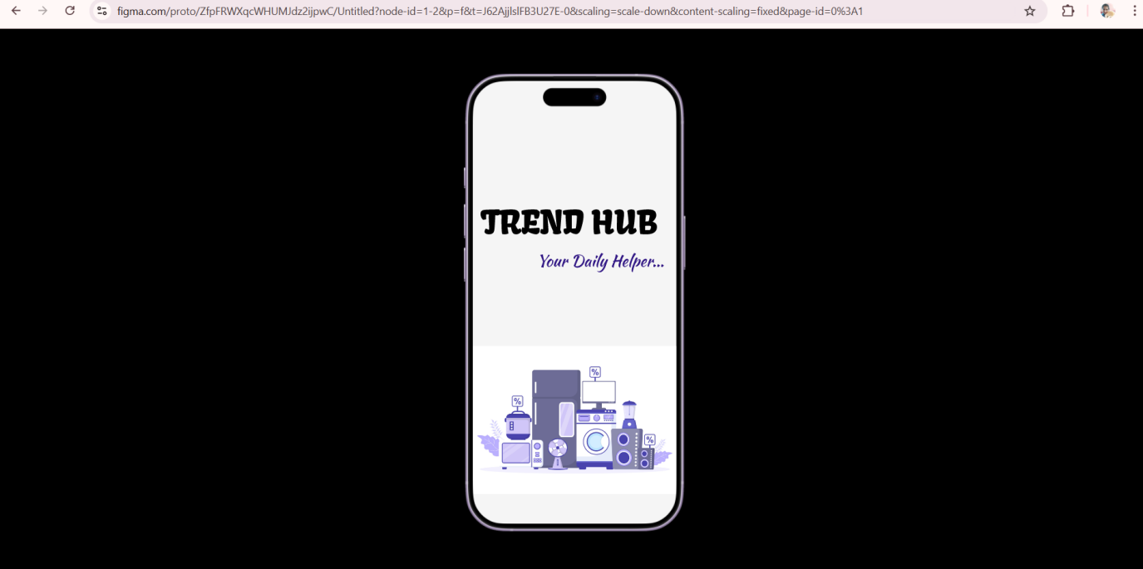

4 | The string is a sequence of characters placed in double quotes (” “). Performing different operations on string data is called String Handling. Strings are immutable. Whenever a change to a String is made, an entirely new String is created. If we want to store a group of characters we can use a char array. String provides various methods to perform different operations on strings. Using Raptor draw a flowchart to display the total number of characters in the string and returns it. | Raptor | CO1

PROCEDURE:
Step 1: Open RAPTOR
- Open RAPTOR application
- Click New Flowchart
Step 2: Insert Start Symbol
- RAPTOR automatically provides Start.
Step 3: Input the String
- Drag Input symbol
- Write:
Input str
Step 4: Process to Find Length
- Drag Assignment symbol
- Write:
count ← length(str)
Step 5: Display Result
- Drag Output symbol
- Write:
Output "Total characters = ", count
Step 6: Stop
- RAPTOR automatically provides Stop.
Step 7: Run the Program
- Click Run ▶
- Enter string:
Example: "Computer"
- Output will be:
Total characters = 8
SCREENSHOT:
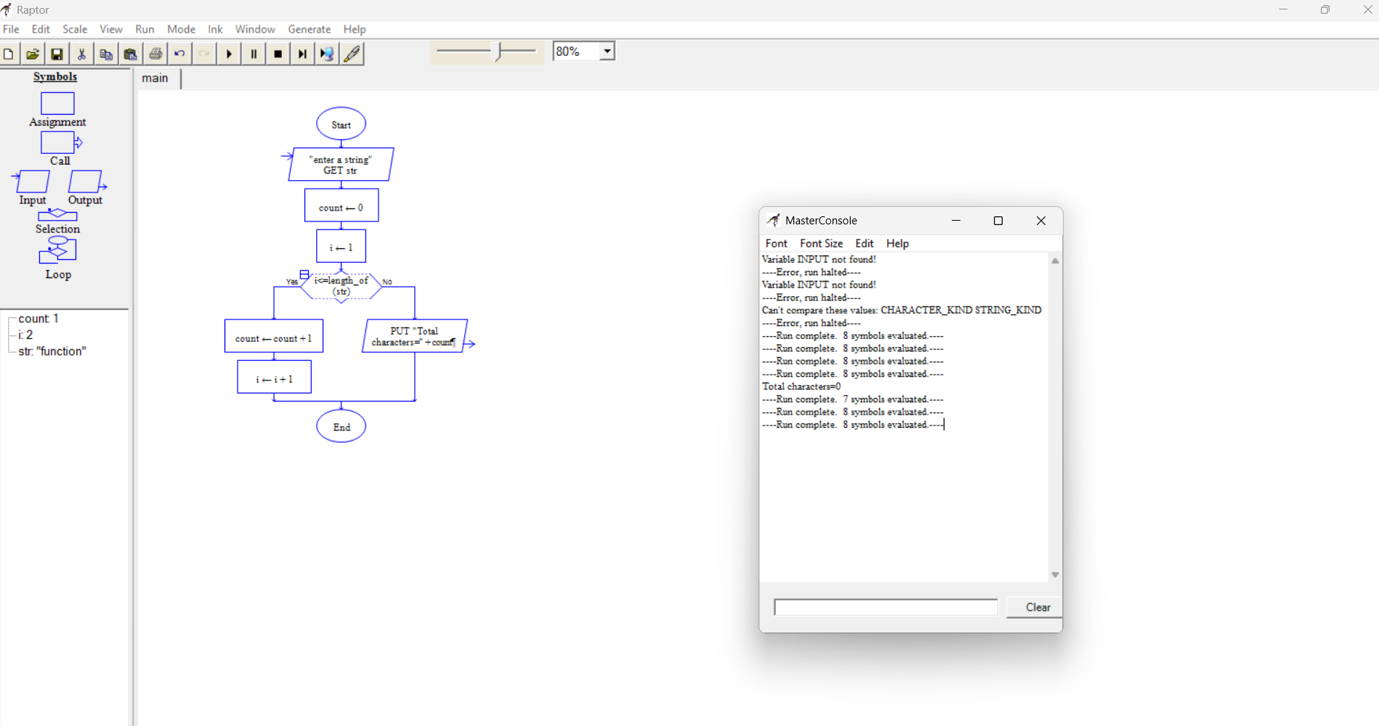

5 | Using Raptor – Draw and validate a flowchart for a given string of lower case English alphabets. One can choose any two characters in the string and replace all the occurrences of the first character with the second character and replace all the occurrences of the second character with the first character. Using Raptor draw and validate the flowchart lexicographically smallest string that can be obtained by doing this operation at most once. | Raptor | CO1

PROCEDURE:
🔹 Step 1: Start RAPTOR
Open RAPTOR → Click New Flowchart
🔹 Step 2: Input String
Insert Input symbol
Input str
🔹 Step 3: Initialize Variables
Insert Assignment symbol
n ← length(str)
found ← false
🔹 Step 4: Outer Loop (i)
Insert Loop symbol (For loop)
for i ← 1 to n
🔹 Step 5: Inner Loop (j)
Inside loop:
for j ← i+1 to n
🔹 Step 6: Decision to Find Smaller Character
Insert Decision symbol
if str[j] < str[i] and found = false
🔹 Step 7: Store Swap Characters
Inside IF:
c1 ← str[i]
c2 ← str[j]
found ← true
🔹 Step 8: End Both Loops
Exit loops once found = true
🔹 Step 9: Replace Characters in String
Insert loop:
for k ← 1 to n
Inside loop:
if str[k] = c1
str[k] ← c2
else if str[k] = c2
str[k] ← c1
end if
🔹 Step 10: Output Result
Insert Output symbol
Output "Lexicographically smallest string = ", str
🔹 Step 11: Stop
SCREENSHOT:
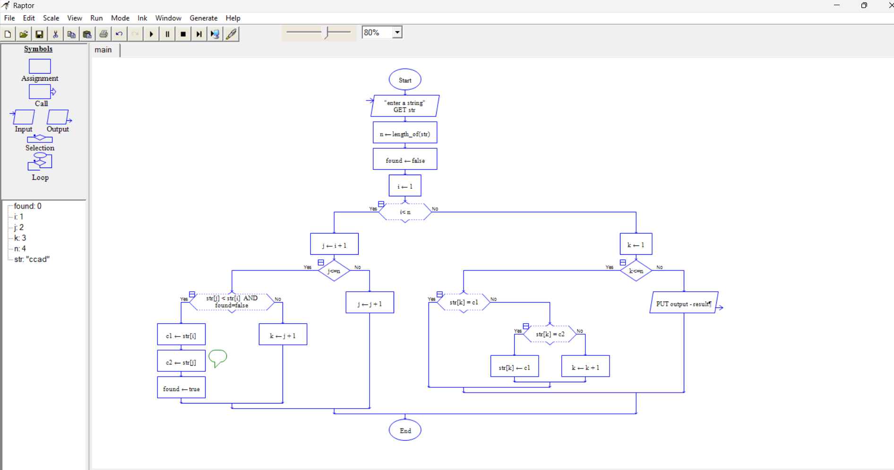

6 | An online food delivery platform enables customers to browse restaurants, view menus, place food orders, make online payments, and track delivery status. Restaurants use the system to manage their menus and update order status, while delivery agents are responsible for accepting delivery requests and updating delivery progress. Design a Class Diagram, Use case Diagram and Activity Diagram for the Online Food Delivery System showing the relevant classes, their attributes, methods, and relationships. | Umbrello | CO1

USE CASE DIAGRAM
PROCEDURE:
Step 1: Create Use Case Diagram
Right click Use Case View → New Diagram
Rename as: FoodDelivery_UseCaseDiagram
Step 2: Add Actors
- Customer
- Restaurant
- Delivery Agent
Step 3: Add Use Cases
Customer Use Cases
- Browse Restaurants
- View Menu
- Place Order
- Make Payment
- Track Delivery
Restaurant Use Cases
- Manage Menu
- Update Order Status
Delivery Agent Use Cases
- Accept Delivery
- Update Delivery Status
Step 4: Connect Actors to Use Cases
Use Association line:
- Customer → all customer use cases
- Restaurant → manage menu, update order
- Delivery Agent → delivery tasks
Step 5: Save Diagram
Save as: FoodDelivery_UseCaseDiagram.uxf
SCREENSHOT:
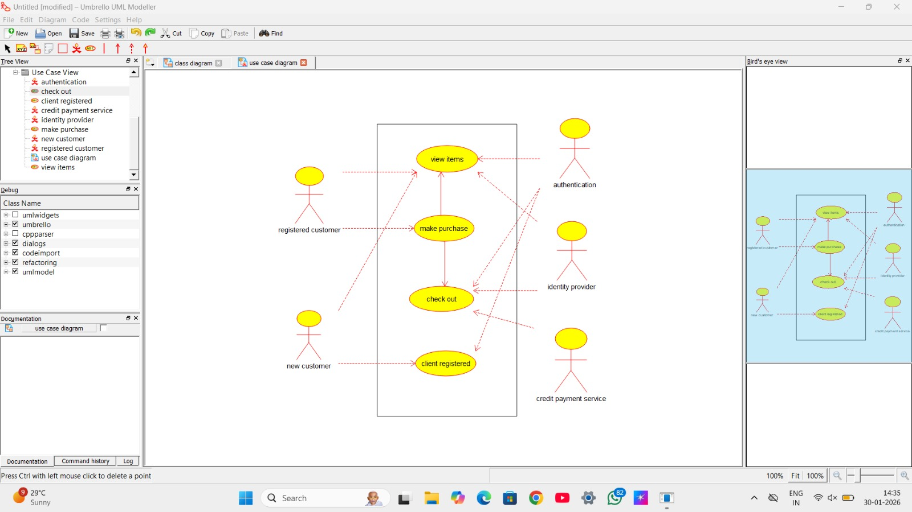
ACTIVITY DIAGRAM
PROCEDURE:
Step 1: Create Activity Diagram
Right click Logical View → New Diagram → Activity Diagram
Rename as: FoodDelivery_ActivityDiagram
Step 2: Add Activities in Sequence
- Start
- Browse Restaurants
- View Menu
- Select Food
- Place Order
- Make Payment
- Order Confirmed
- Restaurant Prepares Food
- Delivery Agent Picks Order
- Deliver Food
- Order Completed
- Stop
Step 3: Connect Flow
Use Control Flow arrows to connect each activity in order.
Step 4: Save Diagram
Save as: FoodDelivery_ActivityDiagram.uxf
SCREENSHOT:

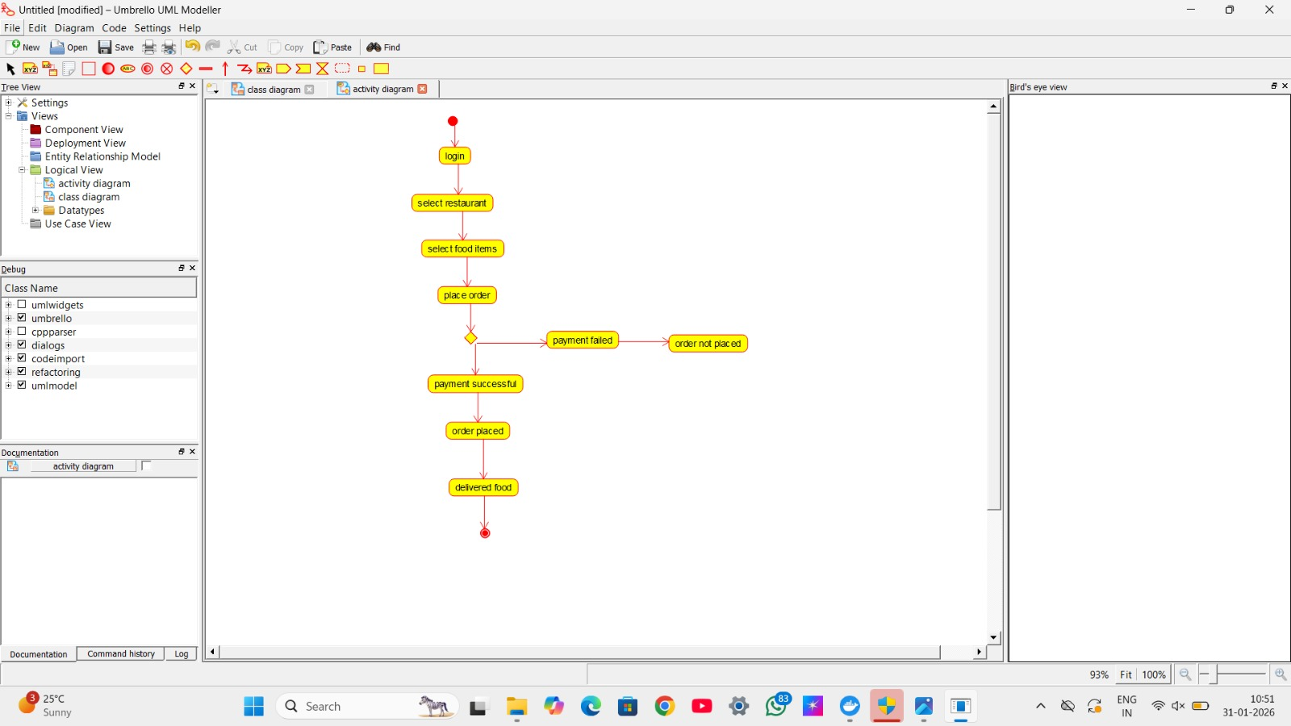

7 | A college employs a large number of security personnel who are assigned duties at various locations across the campus. Each security person follows a duty schedule that includes date, duty start time, duty end time, and assigned location, ensuring that every campus location is covered. If a security person takes leave, it is recorded manually, and at the end of each month, salaries are calculated based on duties performed and leaves taken. Since manual handling of duty allocation, leave management, and salary calculation is time-consuming and complex, the college plans to develop an Online Security Management System to automate these activities. Develop Class Diagram, Use case Diagram and Activity Diagram to represent the workflow of the Online Security Management System. | Umbrello | CO1

ACTIVITY DIAGRAM
PROCEDURE:
Step 1: Create Activity Diagram
Right-click Logical View → New Diagram → Activity Diagram
Rename as:
SecurityManagement_ActivityDiagram
Step 2: Add Activities in Order
- Start
- Admin Assigns Duty
- Security Staff Views Duty
- Security Staff Performs Duty
- Apply Leave (if required)
- Admin Approves Leave
- Monthly Duty Completion
- Calculate Salary
- Generate Salary
- Security Staff Views Salary
- Stop
Step 3: Add Decision Node
After Apply Leave
Decision:
Leave Approved?
- Yes → Continue
- No → Duty Continues
Step 4: Connect All Activities with Arrows
Use control flow arrows to show sequence.
Step 5: Save Diagram
SCREENSHOT:
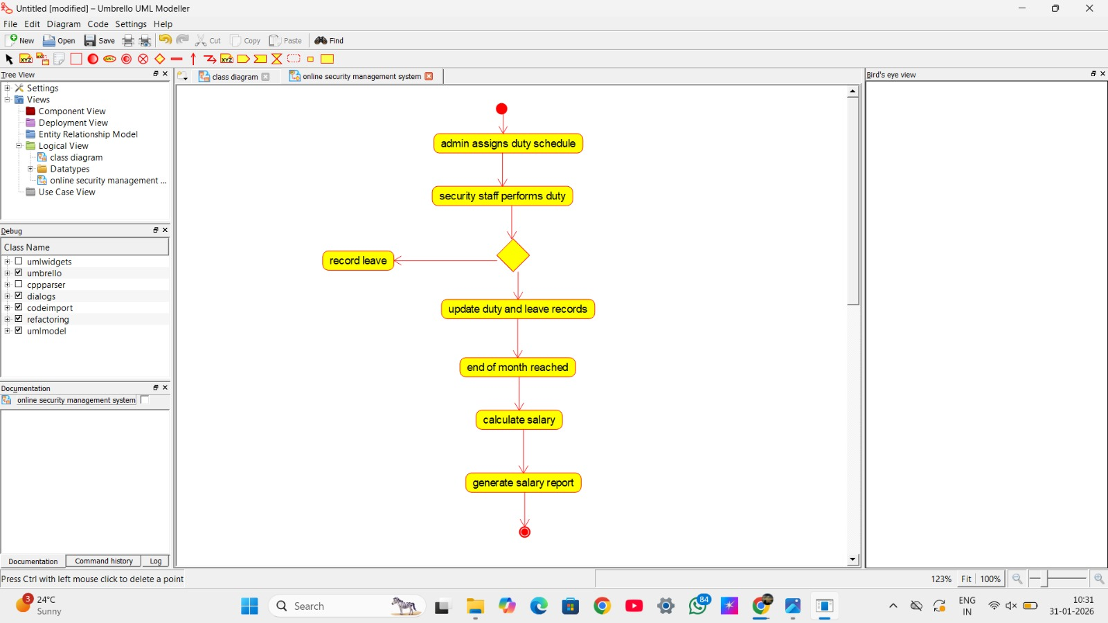

8 | Cyclomatic Complexity in Software Testing is a testing metric used for measuring the complexity of a software program. It is a quantitative measure of independent paths in the source code of a software program. Cyclomatic complexity can be calculated by using control flow graphs or with respect to functions, modules, methods or classes within a software program. Cyclomatic complexity for a flow graph G is V(G)=E-N+2. Cyclomatic complexity is a software metric (measurement), used to indicate the complexity of a program, Cyclomatic complexity = E - N + P where, E = number of edges in the flow graph, N = number of nodes in the flow graph, P = number of nodes that have exit points. Find Cyclomatic Complexity for a graph having number of edges as 17, number of nodes as 13 and number of predicate nodes in the flow graph as 5. | Raptor | CO1

PROCEDURE:

Step 1: Open RAPTOR
Open RAPTOR Flowchart Tool.

Step 2: Insert Input Symbols
Add three Input symbols:
- Input E
- Input N
- Input P
Set prompts:
Enter number of edges:
Enter number of nodes:
Enter number of predicate nodes:

Step 3: Insert Assignment Symbol (Formula 1)
Add an Assignment symbol:
V1 = E - N + 2

Step 4: Insert Assignment Symbol (Formula 2)
Add another Assignment symbol:
V2 = P + 1

Step 5: Insert Output Symbols
Add Output symbols:
Cyclomatic Complexity using E-N+2 = V1
Cyclomatic Complexity using P+1 = V2

Step 6: Flowchart Order
Start
↓
Input E
↓
Input N
↓
Input P
↓
V1 = E - N + 2
↓
V2 = P + 1
↓
Output V1
↓
Output V2
↓
End

Step 7: Sample Input for Lab
E = 17
N = 13
P = 5
SCREENSHOT:


9 | Create a Scrum Project in Jira.  - Add a backlog with at least 5 items (e.g., "Create user registration page", "Develop API for login").  - Prioritize the backlog and create a 1-week sprint.  - Move backlog items into the sprint and start the sprint.  - Finally show the Screenshot of the sprint board at the start and end of the sprint. | Jira | CO2

PROCEDURE:
Step 1: Create a Scrum Project
- Login to Jira.
- Click Projects → Create Project.
- Choose Scrum Software Development template.
- Click Use template.
- Select Team-managed project (recommended for lab).
- Enter:
  - Project Name: Library Scrum Project
  - Key: LSP
- Click Create Project.
Scrum project is created.

Step 2: Open Backlog
- From left menu → Click Backlog.
- You will see Product Backlog and Sprint area.

Step 3: Add Backlog Items (Minimum 5)
Click Create issue or + Create and add the Story type:

Step 4: Prioritize the Backlog
- In Backlog view, drag issues up/down.
- Arrange in this order:
- Create user registration page
- Develop API for login
- Design home page UI
- Implement password reset
- Write unit test cases
Top = Highest priority.

Step 5: Create a 1-Week Sprint
- Click Create Sprint in Backlog.
- Rename sprint as:
- Sprint 1 – User Authentication Module
- Set duration to 1 week when starting sprint.

Step 6: Move Backlog Items to Sprint
Drag all 5 backlog items into Sprint 1 section.
Now Sprint contains all selected tasks.

Step 7: Start the Sprint
- Click Start Sprint.
- Set:
  - Sprint duration: 1 week
  - Start date: Today
- Click Start.
Sprint is now active.

Step 8: Sprint Board at Start
- Click Active Sprint / Board.
- All tasks will be in To Do column.

Step 9: Move Issues During Sprint

Step 10: Complete Sprint (End of Sprint)
- After moving tasks, click Complete Sprint.
- Jira will close sprint and show report.

Step 11: Sprint Board at End

SCREENSHOT: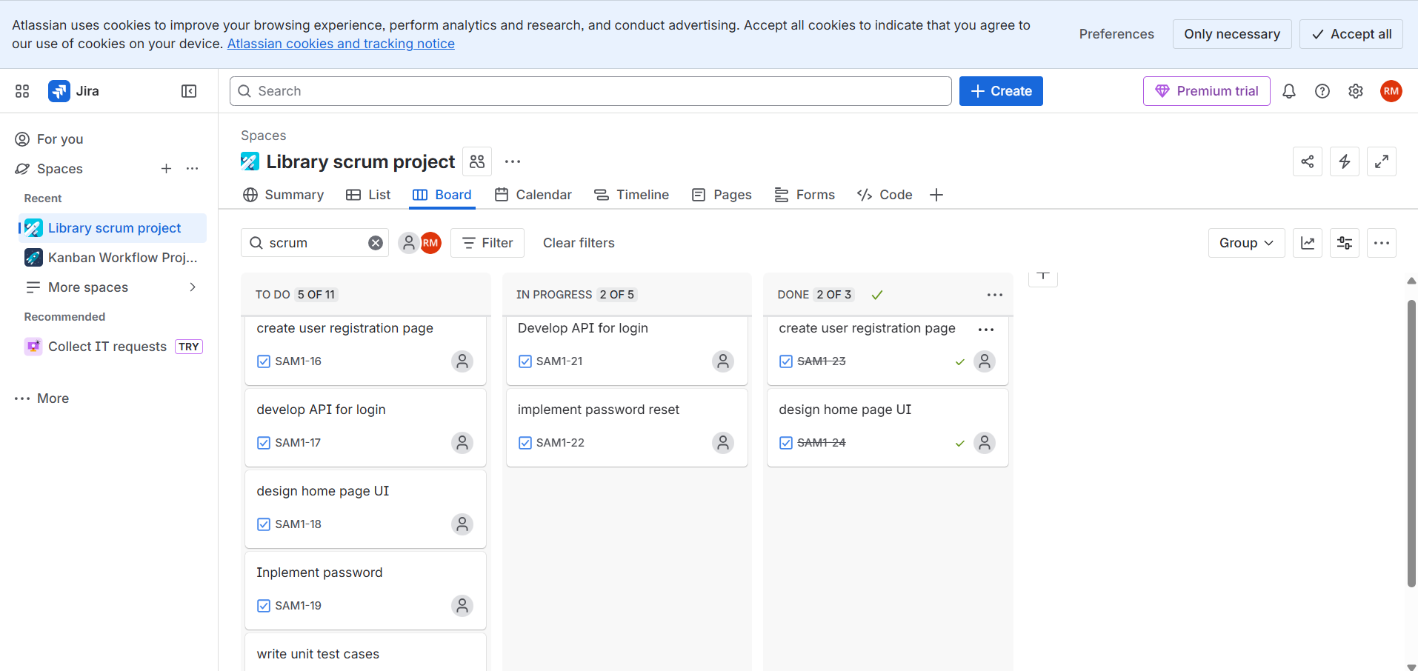
10 | Use the following requirements for a Library Management System:  - Add a feature to search books by title and author.  - Implement an online book reservation system.  - Generate monthly reports on borrowed books for administrators.  - Enable email notifications for overdue books.  - Add support for QR code scanning for borrowing and returning books.  - Create a user-friendly dashboard for librarians.  - Allow users to review and rate books.  - Integrate a chatbot for user assistance.  - Develop a mobile app version of the system.  - Provide multi-language support. | Jira | CO2
PROCEDURE:
🔹 Step 1: Open Spreadsheet
Open:
- Google Sheets → Blank Sheet
OR
- Excel → New Workbook
🔹 Step 2: Create Column Headings
🔹 Step 3: Enter all the Requirements
🔹 Step 4: Apply MoSCoW Categorization
🔹 Step 5: Color Code (Optional but Recommended)
Apply colors:
- Must-Have → Green
- Should-Have → Blue
- Could-Have → Yellow
- Won’t-Have → Red
This improves visual clarity.
🔹 Step 6: Save File
Google Sheets:
File → Share → Copy link
Excel:
File → Save As → Library_MoSCoW.xlsx
SCREENSHORT:
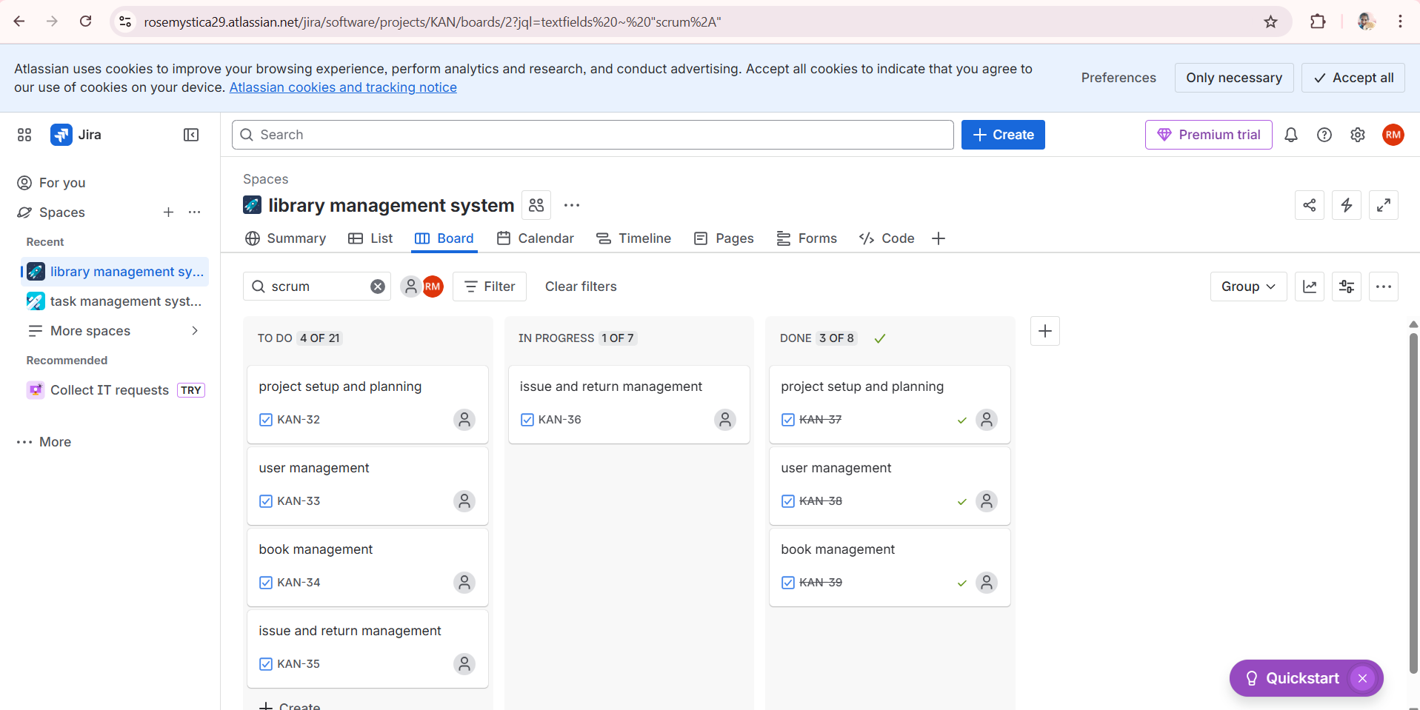

11 | Link Jira tasks with Confluence to streamline task tracking and progress monitoring for the Library Management System development.  - Create a new page in Confluence titled "Library Management System Project Overview."  - Embed at least 5 Jira issues related to the development of the Library Management System (e.g., tasks from the sprint like "Develop book search functionality," "Create user login page," etc.).  - Use the Jira macro to display issues with status (e.g., "To Do," "In Progress," "Done").  - Add a progress bar in the Confluence page to visually track the completion of each embedded Jira task (e.g., percentage of tasks completed in the sprint).  - Submit a screenshot of the Confluence page showing the embedded Jira tasks and the progress bar. | Jira & Confluence | CO2

PROCEDURE:
🔹 Step 1: Create Jira Issues
- Open Jira
- Go to your project → Example:
Library Management System Project
- Create at least 5 issues:
- Assign different statuses:
- To Do
- In Progress
- Done
🔹 Step 2: Open Confluence
- Open Confluence
- Go to your project space.
🔹 Step 3: Create a New Page
- Click Create
- Title the page:
Library Management System Project Overview
- Click Create Page
🔹 Step 4: Add Project Introduction
Type:
This page tracks Jira tasks and progress for the Library Management System development project.
🔹 Step 5: Insert Jira Macro for Issues
- Click + (Insert) → Jira Issue / Jira Macro
- Choose Search for issues
- Select your Jira project
- Filter issues for the sprint
- Click Insert
This embeds all Jira issues.
🔹 Step 6: Display Status Column
In macro settings:
✔ Enable columns:
- Issue Key
- Summary
- Status
- Assignee
Now tasks show To Do, In Progress, Done.
🔹 Step 7: Add Progress Bar
- Click + → Insert → Jira Roadmap / Status Macro / Progress Macro
- Or manually calculate:
Example:
Total Tasks: 5
Completed: 2
Progress: 40%
- Insert Progress Bar Macro
- Set value = 40%
🔹 Step 8: Organize Page Layout
Use headings:
## Sprint Tasks
## Task Status
## Sprint Progress
Place:
- Jira issue table under Sprint Tasks
- Progress bar under Sprint Progress
🔹 Step 9: Save Page
Click Publish
SCREENSHOT:


12 | You are designing a Task Management System for a small team. The system should include the following features:  - User Login and Role Assignment  - Task Creation and Assignment  - Task Prioritization and Deadlines  - Progress Tracking and Reporting  Prioritize these requirements using the MoSCoW and Kano models in Jira. | Jira | CO2

PROCEDURE:

Step 1: Create Jira Project
- Login to Jira
- Click Projects → Create project
- Select Scrum Software Development
- Choose Team-managed project
- Project name: Task Management System
- Click Create

Step 2: Create Backlog Items
Create 4 Story issues

Step 3: Create Custom Field for MoSCoW
- Click ⚙ Settings → Issues
- Click Custom fields → Create custom field
- Select Single Select List
- Name it: MoSCoW Priority
- Add options:
  - Must Have
  - Should Have
  - Could Have
  - Won’t Have
- Associate with Scrum screens.

Step 4: Assign MoSCoW Priority
Open each story and assign:

Step 5: Create Custom Field for Kano Model
- Go to Custom fields → Create
- Choose Single Select List
- Name: Kano Category
- Options:
  - Basic (Must-be)
  - Performance
  - Excitement
  - Indifferent

Step 6: Assign Kano Categories

Step 7: Configure Columns
- Open Backlog
- Click View settings → Columns
- Add:
  - MoSCoW Priority
  - Kano Category
Now backlog shows prioritization clearly.
SCREENSHOT:
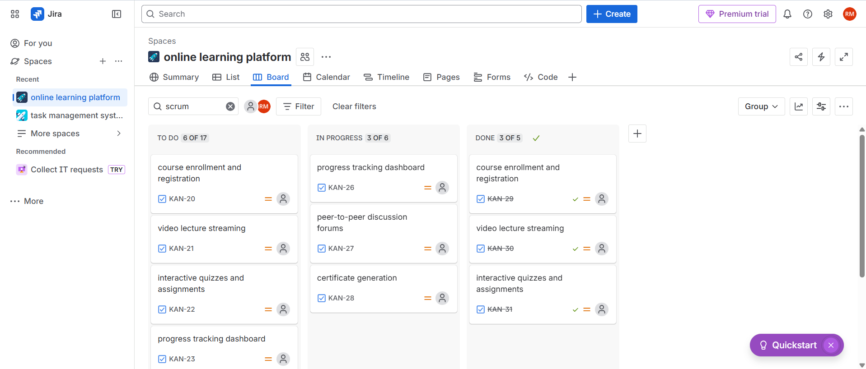

13 | You are tasked with developing an Online Learning Platform. The platform should include the following functionalities:  - Course Enrollment and Registration  - Video Lecture Streaming  - Interactive Quizzes and Assignments  - Progress Tracking Dashboard  - Peer-to-Peer Discussion Forums  - Certificate Generation  Use Jira to categorize and prioritize these requirements using MoSCoW and Kano techniques. | Jira | CO2

PROCEDURE:

Step 1: Create Jira Project
- Login to Jira.
- Click Projects → Create Project.
- Choose Scrum Software Development template.
- Select Team-managed project.
- Enter:
  - Project Name: Online Learning Platform
  - Key: OLP
- Click Create Project.

Step 2: Create Stories
Create 6 Story issues with these titles:

Step 3: Create MoSCoW Custom Field
- Click ⚙ Settings → Issues → Custom fields
- Click Create custom field
- Select Single Select List
- Name it: MoSCoW Priority
- Add values:
  - Must Have
  - Should Have
  - Could Have
  - Won’t Have
- Associate it with Scrum screens.

Step 4: Assign MoSCoW Values
Requirement | MoSCoW
Course Enrollment and Registration | Must Have
Video Lecture Streaming | Must Have
Interactive Quizzes and Assignments | Should Have
Progress Tracking Dashboard | Should Have
Peer-to-Peer Discussion Forums | Could Have
Certificate Generation | Could Have

Step 5: Create Kano Custom Field
- Go to Custom fields → Create
- Select Single Select List
- Name it: Kano Category
- Add options:
  - Basic (Must-Be)
  - Performance
  - Excitement
  - Indifferent

Step 6: Assign Kano Categories

Step 7: Show Custom Fields in Backlog
- Open Backlog
- Click View Settings → Columns
- Add:
  - MoSCoW Priority
  - Kano Category
Now backlog shows both prioritization models.

SCREENSHOT:


14 | Demonstrate how to work collaboratively in Git/GitHub on a project using the fork-and-pull request workflow.  Tasks:  - Fork an existing public GitHub repository (e.g., a sample JavaScript or Python project).  - Clone the forked repository to your local machine using Git.  - Create a new branch for the feature or change you want to work on.  - Make modifications or add new features (e.g., add a function, fix a bug, or update the README).  - Commit your changes and push the branch to GitHub.  - Go to the GitHub repository and create a pull request to merge your feature branch into the main branch.  - Review the pull request and provide feedback on the changes.  Respond to feedback by making additional commits to the feature branch if necessary.  - Once the pull request is approved, merge it into the main branch.  - Finally submit the link to the pull request along with a summary of the changes you made and how you collaborated. | Git/GitHub | CO3

PROCEDURE:

Step 1: Fork a Public Repository
- Go to GitHub.
- Search for a public repository (example: python-sample-project).
- Open the repository.
- Click Fork (top-right corner).
- Select your GitHub account.
Repository is now copied into your account.

Step 2: Clone the Forked Repository
- Open your forked repository.
- Click Code → HTTPS → Copy URL.
- Open Git Bash / Terminal.
- Run:
git clone https://github.com/your-username/repository-name.git
- Move into project folder:
cd repository-name

Step 3: Create a New Feature Branch
git checkout -b feature-readme-update

Step 4: Make Changes
Example: Update README.md
Add:
This project demonstrates collaborative GitHub workflow using pull requests.
Or add a new function in Python/JS file.
Save file.

Step 5: Commit the Changes
git status
git add .
git commit -m "Updated README with collaboration workflow description"

Step 6: Push Branch to GitHub
git push origin feature-readme-update

Step 7: Create Pull Request
- Go to your forked repository on GitHub.
- Click Compare & pull request.
- Set:
  - Base repository: Original repo → main
  - Head repository: Your fork → feature-readme-update
- Add title:
- Updated README for GitHub collaboration workflow
- Add description.
- Click Create pull request.

Step 8: Review and Feedback
- Open Pull Request.
- Click Files changed.
- Add comment like:
- The README improvement clearly explains the collaboration process.
- Submit review.

Step 9: Respond to Feedback
If changes are requested:
- Edit file again locally.
- Commit:
git add .
git commit -m "Improved README based on review feedback"
- Push:
git push origin feature-readme-update
Pull request updates automatically.

Step 10: Merge Pull Request
Once approved:
- Click Merge pull request
- Click Confirm merge
Changes merged into main branch.

Step 11: Final Submission
Submit:
- 🔗 Pull Request Link
- Summary of changes
- Collaboration description
SCREENSHOT:
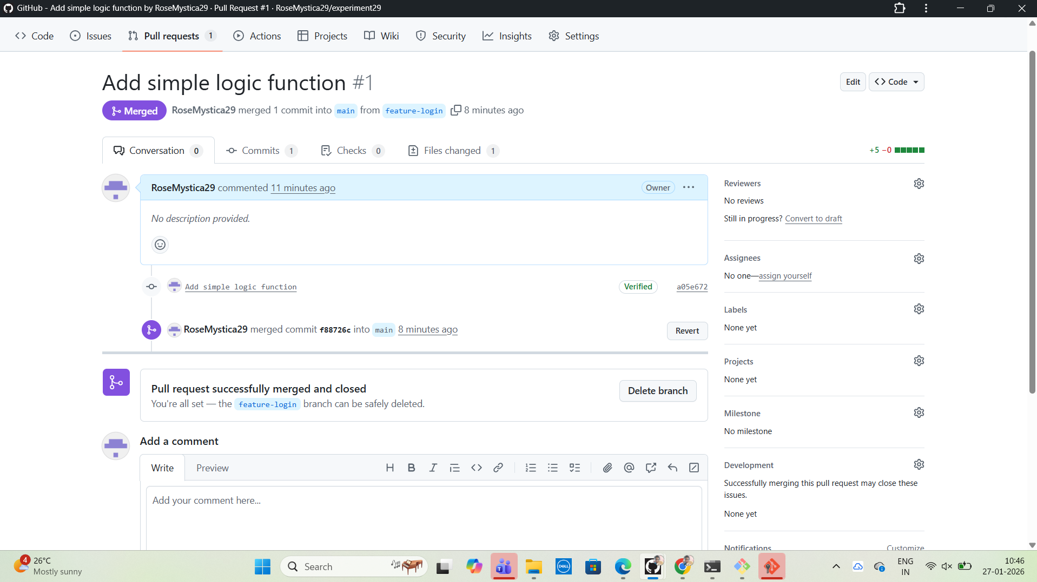

15 | Demonstrate how to work with Git branches and resolve merge conflicts when collaborating with others.  Tasks:  - Clone a shared repository to your local machine.  - Create a new branch and switch to it.  - Make changes to a file (e.g., update a README or modify code in a specific function).  - Commit your changes.  - Push the changes to the remote repository.  - Before merging, pull the latest changes from the main branch.  - Switch back to your feature branch.  - Merge the main branch into your feature branch.  - If there are conflicts, resolve them manually by editing the conflicting files. After resolving conflicts, mark the conflicts as resolved.  - Commit the resolved merge.  - Push your feature branch with the merged changes to GitHub and create a pull request.  - Submit a summary of the steps you performed, the conflicts you encountered, and how you resolved them. | Git/GitHub | CO3

PROCEDURE:

Step 1: Clone Shared Repository
git clone https://github.com/team/repository-name.git
cd repository-name

Step 2: Create and Switch to Feature Branch
git checkout -b feature-update-readme

Step 3: Make Changes
Open README.md and modify a section:
This project demonstrates Git branching and conflict resolution.
Save file.

Step 4: Commit Your Changes
git add README.md
git commit -m "Updated README with branching information"

Step 5: Push Feature Branch
git push origin feature-update-readme

Step 6: Pull Latest Main Branch
Switch to main branch:
git checkout main
git pull origin main

Step 7: Switch Back to Feature Branch
git checkout feature-update-readme

Step 8: Merge Main into Feature Branch
git merge main

Step 9: Resolve Merge Conflicts
If conflict occurs, Git shows:
CONFLICT (content): Merge conflict in README.md
Open the file:
<<<<<<< HEAD
Your change
=======
Main branch change
>>>>>>> main
Edit manually to keep correct content:
Combined final version of README content
Remove conflict markers.

Step 10: Mark Conflict as Resolved
git add README.md
git commit -m "Resolved merge conflict between main and feature branch"

Step 11: Push Updated Feature Branch
git push origin feature-update-readme

Step 12: Create Pull Request
- Go to GitHub
- Click Compare & Pull Request
- Base: main
- Compare: feature-update-readme
- Click Create Pull Request
SCREENSHOT:
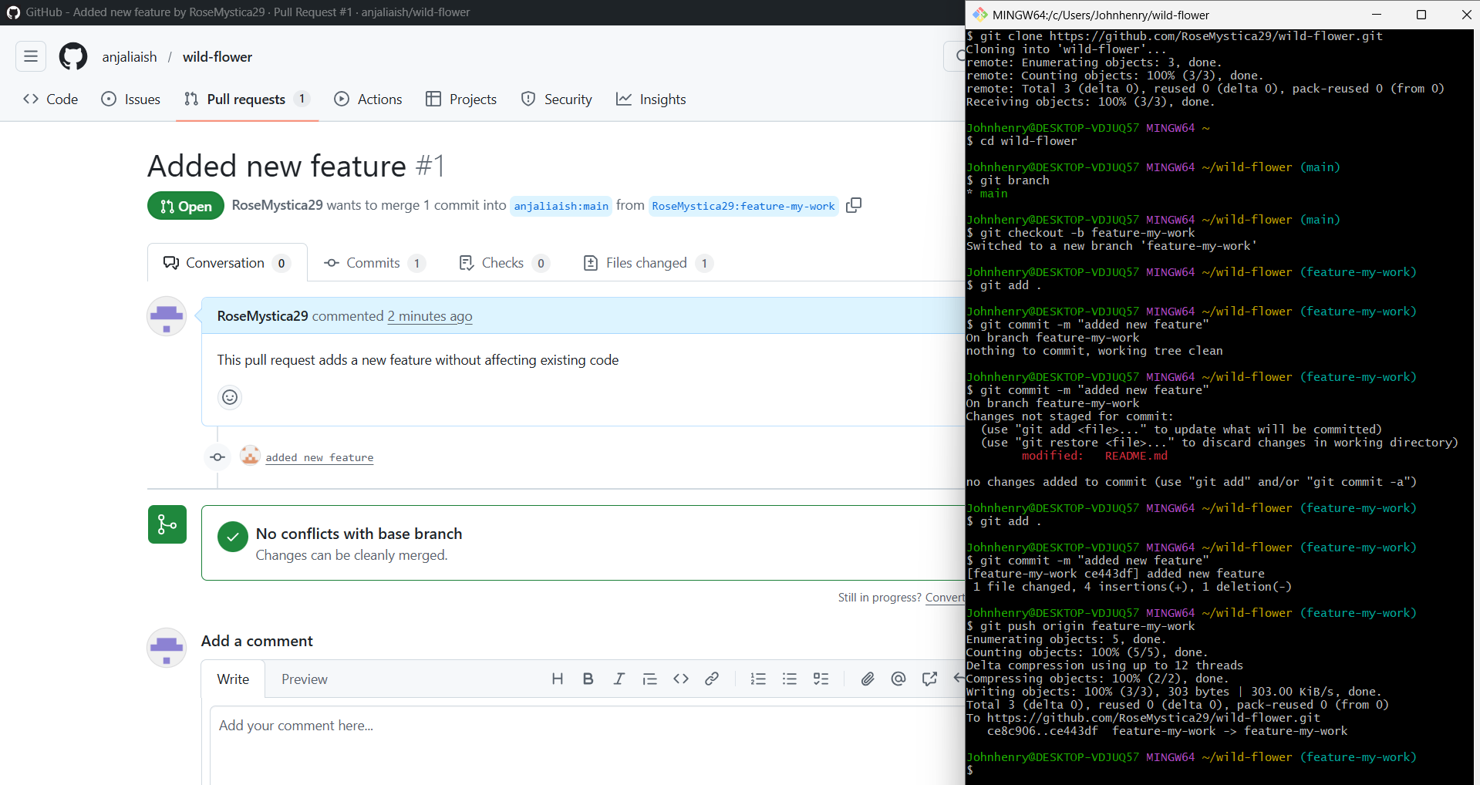
16 | Create a Static Website and Containerize, Build & Serve it using Docker.  Tasks:  - Create a Simple Static Website (index.html file) with basic HTML content.  - Write/create a Dockerfile to serve the website using Nginx.  - Build the Docker Image  - Run the container:  - Access the Website using a Browser | Docker | CO3

PROCEDURE:

Step 1: Create Project Folder
mkdir static-website-docker
cd static-website-docker

🔹 Step 2: Initialize Git Repository
git init

🔹 Step 3: Create Static Website
Create file:
index.html
Add content:
<!DOCTYPE html>
<html>
<head>
<title>My Static Website</title>
</head>
<body>
<h1>Welcome to My Static Website</h1>
<p>This website is served using Docker and Nginx.</p>
</body>
</html>
Save the file.

🔹 Step 4: Create Dockerfile
Create file named Dockerfile (no extension):
FROM nginx:latest
COPY index.html /usr/share/nginx/html/index.html
EXPOSE 80

🔹 Step 5: Check Files
ls
Output:
Dockerfile
index.html

🔹 Step 6: Commit to Git
git add .
git commit -m "Added static website and Dockerfile"

🔹 Step 7: Create GitHub Repository
- Go to GitHub
- Click New Repository
- Name: static-website-docker
- Click Create repository

Step 8: Push Code to GitHub
git branch -M main
git remote add origin https://github.com/your-username/static-website-docker.git
git push -u origin main

Step 9: Build Docker Image
docker build -t static-website .

Step 10: Run Docker Container
docker run -d -p 8080:80 static-website

Step 11: Verify Running Container
docker ps

Step 12: Access Website in Browser
Open browser and go to:
http://localhost:8080
You will see:
Welcome to My Static Website
This website is served using Docker and Nginx.
SCREENSHOT:
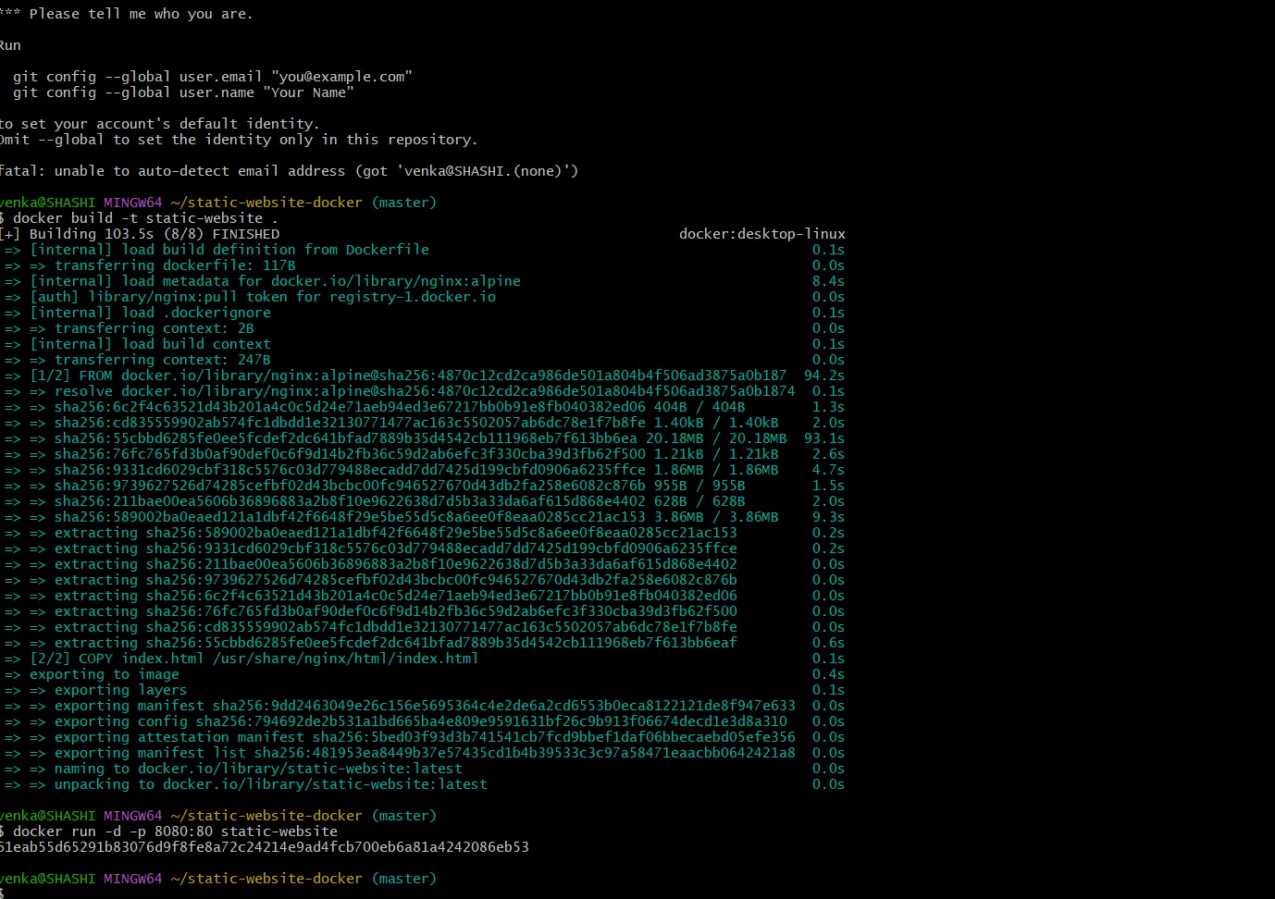
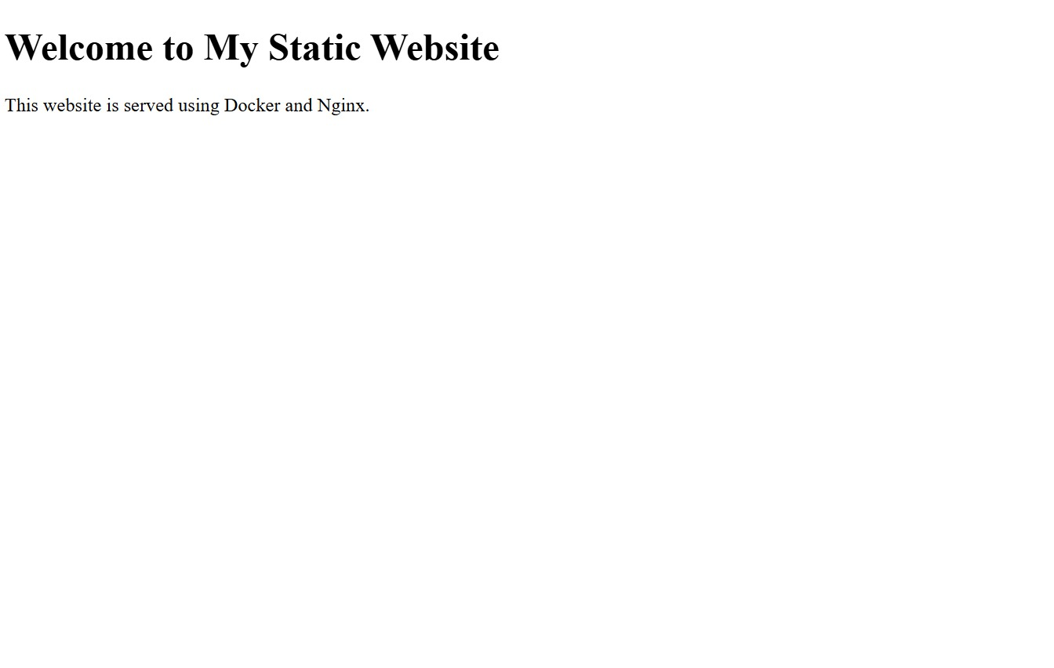

17 | Create a Simple Python Flask API, Containerize the Application, Build & Push the Image using Docker and Deploy the Application using Kubernetes.  Tasks:  - Create a Simple Flask API by writing a Python file (app.py) with basic endpoints.  - Containerize the Flask App using Dockerfile.  - Build the Image using Docker.  - Push the Image to Docker Hub.  - Create Kubernetes manifests (Deployment YAML & Service YAML) to deploy the application.  - Apply the Manifests and Access the API via NodePort. | Docker & Kubernetes | CO3

PROCEDURE:

Step 1: Create Project Folder
mkdir flask-k8s-app
cd flask-k8s-app

Step 2: Create Flask API (app.py)
Create file:
app.py
Add:
from flask import Flask, jsonify
app = Flask(__name__)
@app.route("/")
def home():
return jsonify({"message": "Flask API is running!"})
@app.route("/hello")
def hello():
return jsonify({"message": "Hello from Kubernetes Flask API"})
if __name__ == "__main__":
app.run(host="0.0.0.0", port=5000)

Step 3: Create requirements.txt
Flask

Step 4: Create Dockerfile
FROM python:3.9-slim
WORKDIR /app
COPY requirements.txt .
RUN pip install -r requirements.txt
COPY app.py .
EXPOSE 5000
CMD ["python", "app.py"]

Step 5: Build Docker Image
Replace yourusername with Docker Hub username.
docker build -t yourusername/flask-k8s-api:1.0 .

Step 6: Test Locally
docker run -d -p 5000:5000 yourusername/flask-k8s-api:1.0
Open browser:
http://localhost:5000
http://localhost:5000/hello

Step 7: Login to Docker Hub
docker login

Step 8: Push Image to Docker Hub
docker push yourusername/flask-k8s-api:1.0

Step 9: Create Kubernetes Deployment YAML
Create file:
deployment.yaml
Content:
apiVersion: apps/v1
kind: Deployment
metadata:
name: flask-api-deployment
spec:
replicas: 2
selector:
matchLabels:
app: flask-api
template:
metadata:
labels:
app: flask-api
spec:
containers:
- name: flask-api
image: yourusername/flask-k8s-api:1.0
ports:
- containerPort: 5000

Step 10: Create Kubernetes Service YAML
Create:
service.yaml
Content:
apiVersion: v1
kind: Service
metadata:
name: flask-api-service
spec:
type: NodePort
selector:
app: flask-api
ports:
- port: 5000
targetPort: 5000
nodePort: 30007

Step 11: Apply Kubernetes Manifests
kubectl apply -f deployment.yaml
kubectl apply -f service.yaml

Step 12: Verify Pods and Service
kubectl get pods
kubectl get svc

Step 13: Access API from Browser
If using Minikube:
minikube ip
Then open:
http://<minikube-ip>:30007
http://<minikube-ip>:30007/hello
SCREENSHOT:
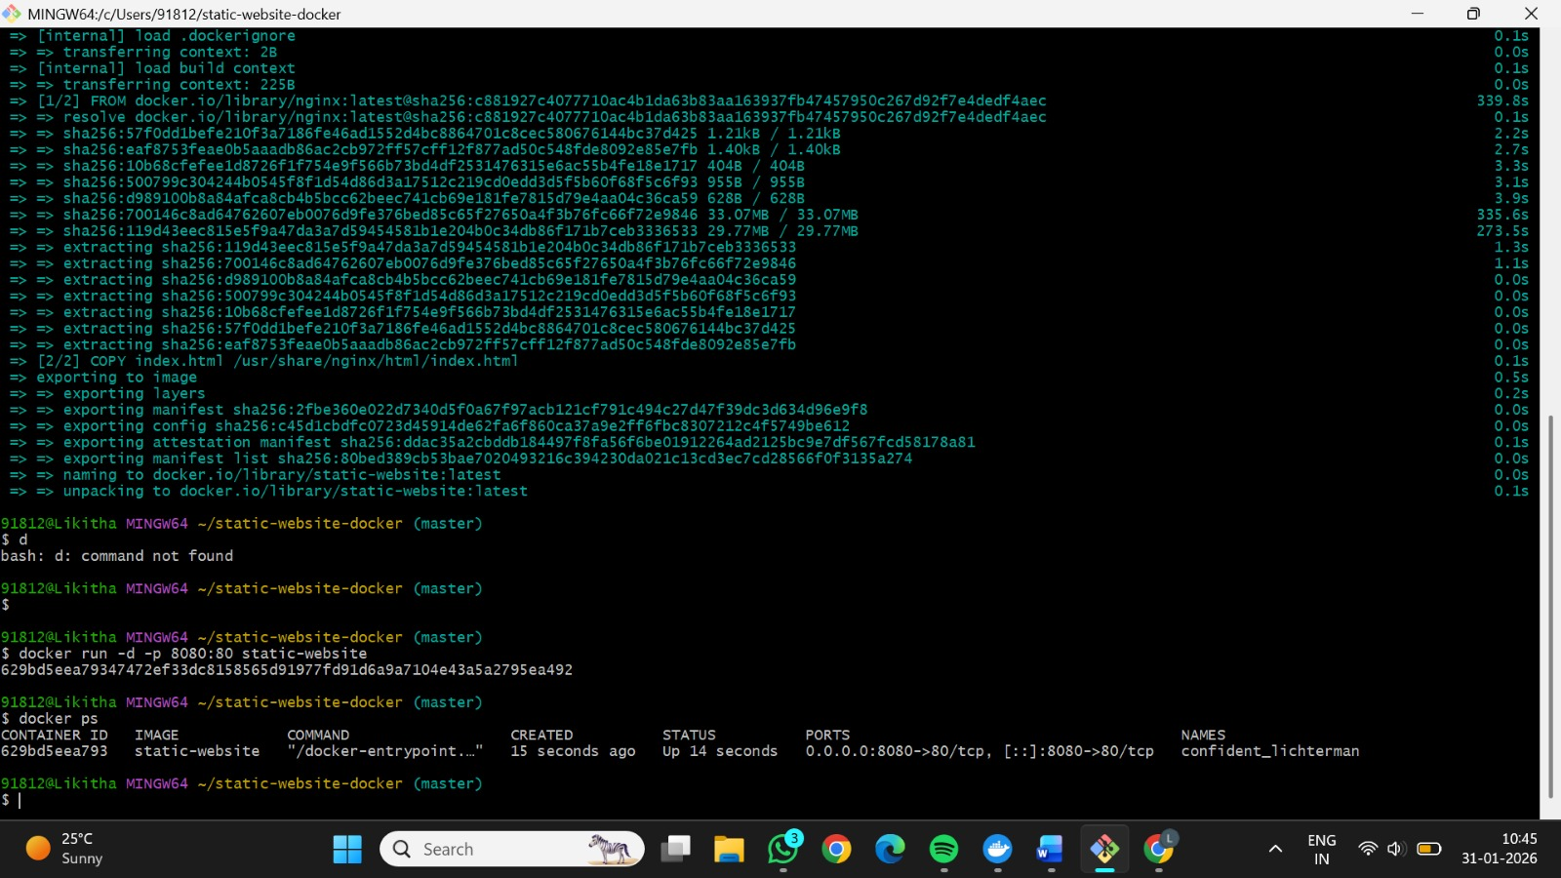
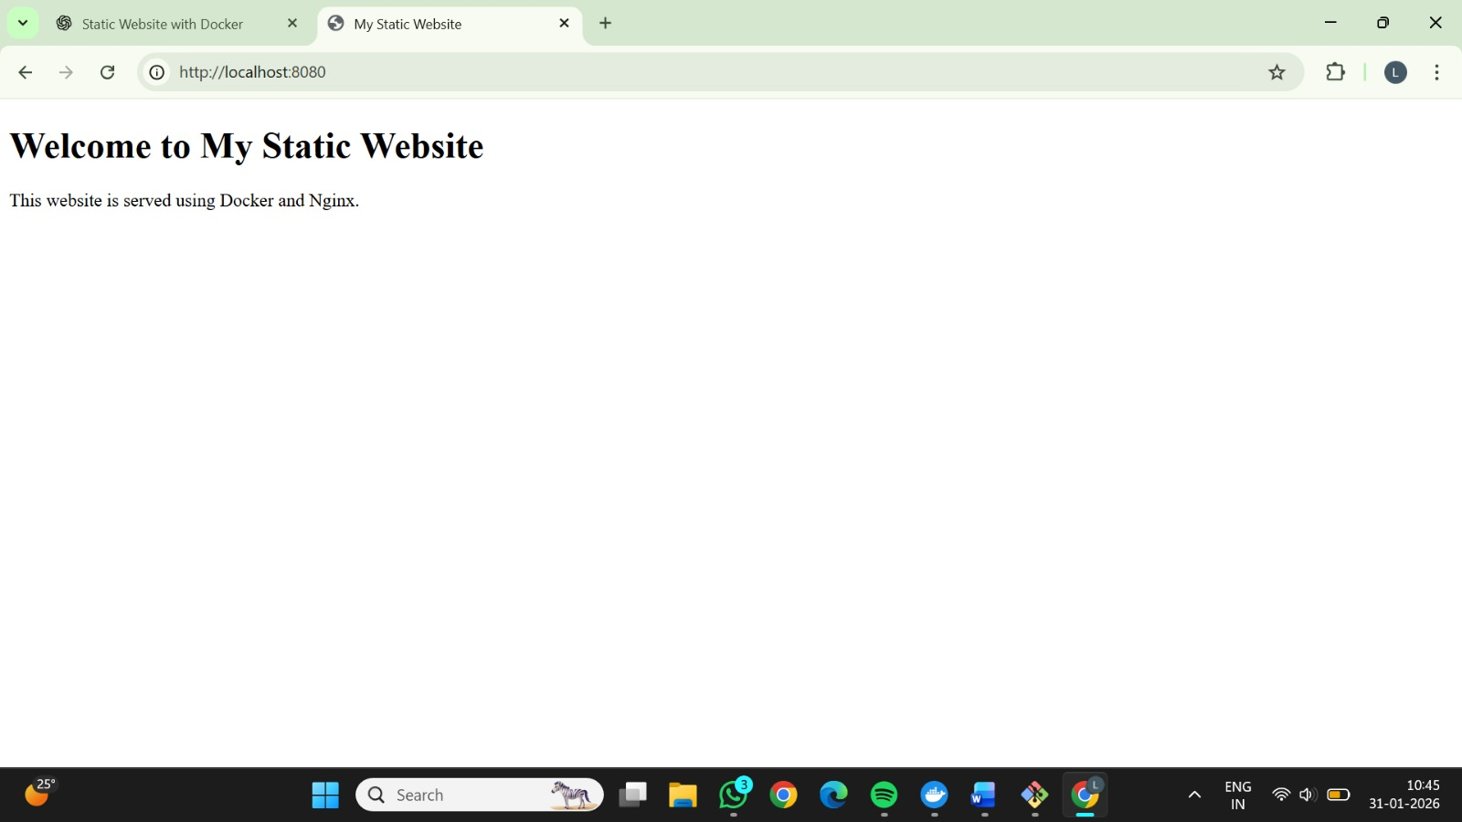

18 | Set up a CI/CD pipeline to automate the building, testing, and deployment of a containerized application.  Tasks:  - Set up Jenkins on a local machine or server.  - Create a Dockerfile to containerize a sample application.  - Write a Jenkinsfile to automate the process of building the Docker container, running tests, and deploying to a cloud platform (e.g., AWS or GCP).  - Configure Jenkins to trigger builds upon code commits or pull requests. | Docker | CO4

PROCEDURE:

Step 1: Install Jenkins using Docker (Easy method)
docker run -d -p 8080:8080 -p 50000:50000 --name jenkins \
-v jenkins_home:/var/jenkins_home jenkins/jenkins:lts

Step 2: Get Jenkins Admin Password
docker exec jenkins cat /var/jenkins_home/secrets/initialAdminPassword
Open browser:
http://localhost:8080
Paste password → Install suggested plugins → Create admin user.

Step 3: Create project folder
mkdir cicd-docker-app
cd cicd-docker-app

Step 4: Create app.py
from flask import Flask
app = Flask(__name__)
@app.route("/")
def home():
return "CI/CD Pipeline with Jenkins and Docker"
if __name__ == "__main__":
app.run(host="0.0.0.0", port=5000)

Step 5: Create requirements.txt
Flask

Step 6: Dockerfile
FROM python:3.9-slim
WORKDIR /app
COPY requirements.txt .
RUN pip install -r requirements.txt
COPY app.py .
EXPOSE 5000
CMD ["python","app.py"]

PART 4 — Push Code to GitHub
git init
git add .
git commit -m "Initial CI/CD app"
git branch -M main
git remote add origin https://github.com/yourusername/cicd-docker-app.git
git push -u origin main

PART 5 — Create Jenkinsfile

Step 7: Create Jenkinsfile
pipeline {
agent any
environment {
IMAGE_NAME = "yourusername/cicd-docker-app"
TAG = "latest"
}
stages {
stage('Clone Repo') {
steps {
git 'https://github.com/yourusername/cicd-docker-app.git'
}
}

stage('Build Docker Image') {
steps {
sh 'docker build -t $IMAGE_NAME:$TAG .'
}
}
stage('Run Tests') {
steps {
echo "Running tests..."
sh 'docker run --rm $IMAGE_NAME:$TAG python -c "print(\"Tests Passed\")"'
}
}
stage('Push Image to Docker Hub') {
steps {
withCredentials([usernamePassword(credentialsId: 'dockerhub', usernameVariable: 'USER', passwordVariable: 'PASS')]) {
sh 'echo $PASS | docker login -u $USER --password-stdin'
sh 'docker push $IMAGE_NAME:$TAG'
}
}
}
stage('Deploy Container') {
steps {
sh '''
docker stop cicd-container || true
docker rm cicd-container || true
docker run -d -p 5000:5000 --name cicd-container $IMAGE_NAME:$TAG
'''
}
}
}
}

PART 6 — Configure Jenkins Job

Step 8: Create Jenkins Pipeline Job
- Jenkins Dashboard → New Item
- Name: CI-CD-Docker-Pipeline
- Select Pipeline → OK

Step 9: Configure Pipeline
In pipeline section:
- Definition: Pipeline script from SCM
- SCM: Git
- Repo URL: GitHub repo URL
- Branch: main
- Script Path: Jenkinsfile
Save.

PART 7 — Add Docker Hub Credentials
- Jenkins → Manage Jenkins → Credentials
- Add Docker Hub username & password
- ID: dockerhub

PART 8 — Enable Auto Trigger

Step 10: Enable GitHub Webhook
In GitHub repo:
Settings → Webhooks → Add webhook
Payload URL:
http://<jenkins-ip>:8080/github-webhook/
Content type: application/json
Enable push events.

Step 11: Enable Jenkins Trigger
In Jenkins job:
GitHub hook trigger for GITScm polling
Save.

PART 9 — Trigger Pipeline
Make any code change and push:
git commit -am "Pipeline trigger test"
git push
Jenkins pipeline runs automatically.

PART 10 — Verify Deployment
Open browser:
http://localhost:5000
Output:
CI/CD Pipeline with Jenkins and Docker
SCREENSHOT:

19 | Implement Continuous Deployment using GitHub Actions to deploy a Dockerized application.  Tasks:  - Set up a GitHub repository and push a simple Dockerized application.  - Create a GitHub Actions workflow to automatically build and push the Docker image to Docker Hub or GitHub Container Registry.  - Automate deployment to a cloud platform (e.g., AWS ECS, Azure Kubernetes Service, or Google Kubernetes Engine).  - Test the CI/CD pipeline by pushing new code changes and verifying that the deployment occurs automatically. | Docker | CO4

PROCEDURE:

Step 1: Create Project Folder
mkdir github-actions-docker
cd github-actions-docker

Step 2: Create app.py
from flask import Flask
app = Flask(__name__)
@app.route("/")
def home():
return "Continuous Deployment using GitHub Actions"
if __name__ == "__main__":
app.run(host="0.0.0.0", port=5000)

Step 3: Create requirements.txt
Flask

Step 4: Create Dockerfile
FROM python:3.9-slim
WORKDIR /app
COPY requirements.txt .
RUN pip install -r requirements.txt
COPY app.py .
EXPOSE 5000
CMD ["python","app.py"]

PART 2 — Push Project to GitHub

Step 5: Initialize Git
git init
git add .
git commit -m "Initial Dockerized Flask app"

Step 6: Create GitHub Repository
Name: github-actions-docker

Step 7: Push to GitHub
git branch -M main
git remote add origin https://github.com/yourusername/github-actions-docker.git
git push -u origin main

PART 3 — Create GitHub Actions Workflow

Step 8: Create Workflow Folder
mkdir -p .github/workflows

Step 9: Create workflow file
File name:
.github/workflows/docker-deploy.yml

Step 10: Workflow Content
name: Docker CI/CD Pipeline
on:
push:
branches: [ "main" ]
jobs:
build-push-deploy:
runs-on: ubuntu-latest
steps:
- name: Checkout code
uses: actions/checkout@v3
- name: Login to Docker Hub
uses: docker/login-action@v2
with:
username: ${{ secrets.DOCKER_USERNAME }}
password: ${{ secrets.DOCKER_PASSWORD }}
- name: Build Docker Image
run: docker build -t ${{ secrets.DOCKER_USERNAME }}/github-actions-app:latest .
- name: Push Docker Image
run: docker push ${{ secrets.DOCKER_USERNAME }}/github-actions-app:latest
- name: Deploy to Server via SSH
uses: appleboy/ssh-action@v1.0.3
with:
host: ${{ secrets.SERVER_IP }}
username: ${{ secrets.SERVER_USER }}
key: ${{ secrets.SERVER_KEY }}
script: |
docker pull ${{ secrets.DOCKER_USERNAME }}/github-actions-app:latest
docker stop github-actions-app || true
docker rm github-actions-app || true
docker run -d -p 5000:5000 --name github-actions-app ${{ secrets.DOCKER_USERNAME }}/github-actions-app:latest

PART 4 — Configure GitHub Secrets
Go to:
GitHub Repo → Settings → Secrets → Actions → New Repository Secret

PART 5 — Prepare Cloud Server
On AWS EC2 / Azure VM / GCP VM:
sudo apt update
sudo apt install docker.io -y
sudo systemctl start docker
sudo usermod -aG docker $USER
Restart session.

PART 6 — Trigger Pipeline

Step 11: Make Code Change
Edit app.py:
return "Auto deployed using GitHub Actions CI/CD"

Step 12: Push Change
git add .
git commit -m "Trigger GitHub Actions deployment"
git push

PART 7 — Verify Pipeline
- Go to GitHub → Actions tab
- Watch workflow run successfully
- Docker image pushed to Docker Hub
- Container redeployed automatically on serve.

PART 8 — Access Application
Open browser:
http://<SERVER_IP>:5000
Output:
Auto deployed using GitHub Actions CI/CD
SCREENSHOT:


20 | Create a GitHub Repository and Implement Version Control  Tasks:  - Set up a repository for a team project.  - Create branches for individual modules.  - Merge branches with pull requests after code reviews.  - Resolve conflicts during branch merging.  - Document the workflow using the README file.  - Submit the repository link | Git/GitHub | CO3

PROCEDURE:

Step 1: Create GitHub Repository
- Login to GitHub.
- Click New Repository.
- Enter:
  - Repository Name: team-project-version-control
  - Visibility: Public / Private
- Click Create Repository.

Step 2: Clone Repository
git clone https://github.com/yourusername/team-project-version-control.git
cd team-project-version-control

Step 3: Create README File
touch README.md
Add:
# Team Project Version Control
This repository demonstrates GitHub version control workflow using branches and pull requests.
Commit:
git add README.md
git commit -m "Added README file"
git push

Step 4: Create Branches for Modules
git checkout -b module-auth
git checkout main
git checkout -b module-ui
git checkout main
git checkout -b module-api
git checkout main

Step 5: Work on Module Branch
Example for module-auth:
git checkout module-auth
touch auth.txt
echo "Authentication module code" > auth.txt
git add auth.txt
git commit -m "Added authentication module file"
git push origin module-auth
Repeat similar steps for other branches.

Step 6: Create Pull Request
- Go to GitHub repo.
- Click Compare & Pull Request.
- Base: main
- Compare: module-auth
- Add title and description.
- Click Create Pull Request.

Step 7: Code Review
Add review comment:
Code looks good. Ready to merge.
Approve pull request.

Step 8: Merge Pull Request
Click Merge Pull Request → Confirm Merge.

Step 9: Simulate Conflict
- Edit README.md in main branch and commit.
- Edit same line in module-ui branch and commit.
- Create pull request from module-ui to main.
- GitHub shows conflict.

Step 10: Resolve Conflict
- Click Resolve conflicts.
- Manually edit content.
- Remove conflict markers.
- Mark as resolved and commit.

Step 11: Update README Workflow Documentation
Edit README.md:
## Workflow
1. Create feature branches for modules.
2. Commit changes to respective branches.
3. Create pull requests.
4. Review and approve changes.
5. Resolve conflicts manually if any.
6. Merge into main branch.
Commit and push.
SCREENSHOT:


21 | Containerize a Python Flask Application Using Docker Tasks:  ● Write a simple Python Flask application for a "To-Do" list.  ● Create a Dockerfile to containerize the application.  ● Build and run the Docker container locally.  ● Test the application’s functionality inside the container.  ● Push the Docker image to Docker Hub.  ● Submit the Dockerfile and screenshots of testing results | Docker, Flask | CO3

PROCEDURE:

Step 1: Create Project Directory
Create a new folder for the Flask application and navigate into it.
todo-flask-app/

Step 2: Write a Simple Flask To-Do Application
Create a file named app.py and implement a basic To-Do list using Flask.
Features:
Add tasks
View task list
Also create a requirements.txt file containing:
flask

Step 3: Test the Flask App Locally
Run the application locally to ensure it works before Dockerizing.
python app.py
Open browser and verify the To-Do app runs on:
http://localhost:5000

Step 4: Create Dockerfile
Create a Dockerfile in the project directory to define how the Flask app is containerized.
Dockerfile tasks include:
Use Python base image
Copy application files
Install dependencies
Expose port 5000
Run Flask app

Step 5: Build Docker Image
Build the Docker image using the Dockerfile.
docker build -t flask-todo-app .

Step 6: Run Docker Container
Run the container and map the container port to the local machine.
docker run -p 5000:5000 flask-todo-app

Step 7: Test Application Inside Container
Open the browser and verify the To-Do application is working inside the Docker container.
http://localhost:5000
✔ Add tasks
✔ View tasks

Step 8: Push Docker Image to Docker Hub
Login to Docker Hub:
docker login
Tag the image:
docker tag flask-todo-app <dockerhub-username>/flask-todo-app
Push the image:
docker push <dockerhub-username>/flask-todo-app
SCREENSHOT:


25 | Create a new GitHub repository for a personal project. Initialize the repository with a README.md file. Then, clone the repository to your local machine, make some changes to the README.md (e.g., add a project description), and push the changes back to GitHub.  Tasks:  ● Create a GitHub repository.  ● Clone the repository to your local machine.  ● Edit the README.md file.  ● Stage, commit, and push your changes to GitHub. | Git/GitHub | CO3
PROCEDURE:

Step 1: Create a New GitHub Repository

Open https://github.com
Click New Repository
Enter repository name (e.g., personal-project)
Select Public (or Private if required)
Check Initialize this repository with a README
Click Create Repository

Step 2: Copy Repository Clone URL
Open the newly created repository
Click Code
Copy the HTTPS URL

Step 3: Clone the Repository to Local Machine
Open Git Bash / Terminal and run:
git clone https://github.com/username/personal-project.git

Step 4: Navigate to the Repository Folder
cd personal-project

Step 5: Edit the README.md File
1.Open README.md using Notepad / VS Code
2.Add project description, for example:
# Personal Project
This is my personal GitHub project created to practice Git and GitHub operations.
Save the file

Step 6: Stage the Changes
git add README.md

Step 7: Commit the Changes
git commit -m "Added project description to README"

Step 8: Push Changes to GitHub
git push origin main
SCREENSHOT:
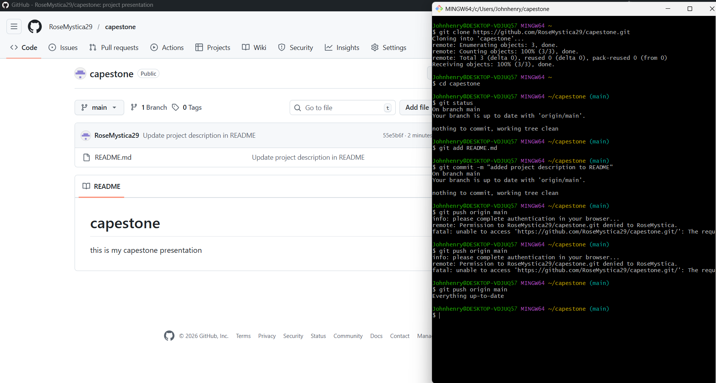

27 | After modifying a file in a cloned repository, commit the changes locally and push them to GitHub.  Tasks:  ● Clone a repository (from question 1).  ● Modify a file (e.g., README.md).  ● Stage the changes with git add.  ● Commit the changes with git commit -m "Updated README".  ● Push the changes to GitHub using git push. | Git/GitHub | CO4
PROCEDURE:

Step 1: Create a New GitHub Repository

Open https://github.com
Click New Repository
Enter repository name (e.g., personal-project)
Select Public (or Private if required)
Check Initialize this repository with a README
Click Create Repository

Step 2: Copy Repository Clone URL
Open the newly created repository
Click Code
Copy the HTTPS URL

Step 3: Clone the Repository to Local Machine
Open Git Bash / Terminal and run:
git clone https://github.com/username/personal-project.git

Step 4: Navigate to the Repository Folder
cd personal-project

Step 5: Edit the README.md File
1.Open README.md using Notepad / VS Code
2.Add project description, for example:
# Personal Project
This is my personal GitHub project created to practice Git and GitHub operations.
Save the file

Step 6: Stage the Changes
git add README.md

Step 7: Commit the Changes
git commit -m "Added project description to README"

Step 8: Push Changes to GitHub
git push origin main
SCREENSHOT:
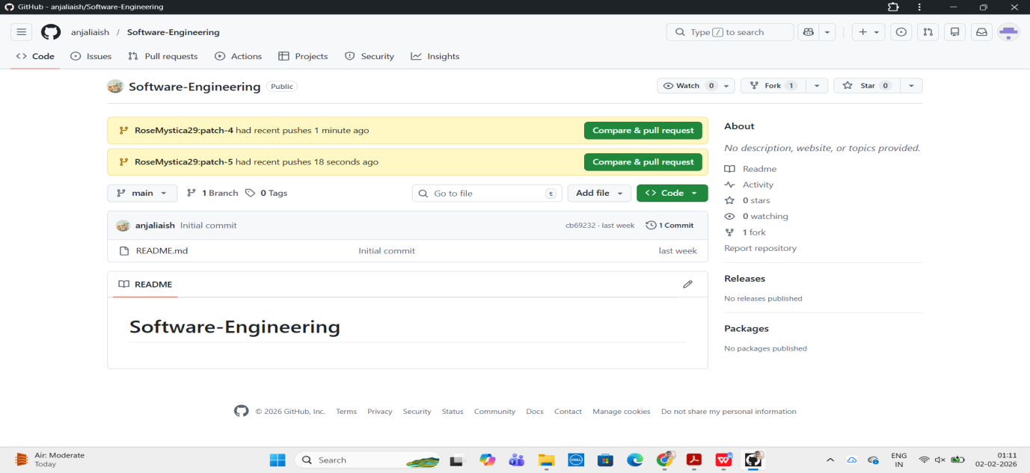
30 | You and your team are working on a project. One team member adds a new feature to the project. You need to fetch the latest changes, create a new branch, and implement your feature without affecting the existing code.  Tasks:  ● Fork a repository (you can use an existing repository or a partner’s repository).  ● Clone the repository to your local machine.  ● Create a new branch for your feature.  ● Implement your changes and push them to your forked repository.  ● Submit a pull request to the original repository. | Git/GitHub | CO4
PROCEDURE:

Step 1: Fork the Original Repository
Open the original repository on GitHub
Click Fork (top-right corner)
A copy of the repository is created in your GitHub account
This allows you to work independently without affecting the main project

Step 2: Clone the Forked Repository to Local Machine
Open Git Bash / Terminal and run:
git clone https://github.com/your-username/repository-name.git

Step 3: Navigate to Project Directory
cd repository-name

Step 4: Fetch Latest Changes from Original Repository
Add the original repository as an upstream remote:
git remote add upstream https://github.com/original-owner/repository-name.git
Fetch latest changes:
git fetch upstream
Merge them into your local main branch:
git checkout main
git merge upstream/main

Step 5: Create a New Feature Branch
Create and switch to a new branch:
git checkout -b feature-my-feature
This ensures your work does not affect existing code

Step 6: Implement Your Feature
Modify or add files as required
Save the changes
Verify functionality locally (if applicable)

Step 7: Stage and Commit Changes
git add .
git commit -m "Implemented new feature"

Step 8: Push Feature Branch to Forked Repository
git push origin feature-my-feature

Step 9: Create a Pull Request
Go to your forked repository on GitHub
Click Compare & pull request
Add title and description
Click Create pull request
Changes are now submitted for review to the original repository
SCREENSHOT:


14 | Demonstrate how to work collaboratively in Git/GitHub on a project using the fork-and-pull request workflow.  Tasks:  1. Fork an existing public GitHub repository (e.g., a sample JavaScript or Python project).  2. Clone the forked repository to your local machine using Git.  3. Create a new branch for the feature or change you want to work on.  4. Make modifications or add new features (e.g., add a function, fix a bug, or update the README).  5. Commit your changes and push the branch to GitHub.  6. Go to the GitHub repository and create a pull request to merge your feature branch into the main branch.  7. Review the pull request and provide feedback on the changes.  8. Respond to feedback by making additional commits to the | Git/GitHub | CO3

PROCEDURE:

Step 1: Fork a Public Repository
- Go to GitHub.
- Search for a public repository (example: python-sample-project).
- Open the repository.
- Click Fork (top-right corner).
- Select your GitHub account.
Repository is now copied into your account.

Step 2: Clone the Forked Repository
- Open your forked repository.
- Click Code → HTTPS → Copy URL.
- Open Git Bash / Terminal.
- Run:
git clone https://github.com/your-username/repository-name.git
- Move into project folder:
cd repository-name

Step 3: Create a New Feature Branch
git checkout -b feature-readme-update

Step 4: Make Changes
Example: Update README.md
Add:
This project demonstrates collaborative GitHub workflow using pull requests.
Or add a new function in Python/JS file.
Save file.

Step 5: Commit the Changes
git status
git add .
git commit -m "Updated README with collaboration workflow description"

Step 6: Push Branch to GitHub
git push origin feature-readme-update

Step 7: Create Pull Request
- Go to your forked repository on GitHub.
- Click Compare & pull request.
- Set:
  - Base repository: Original repo → main
  - Head repository: Your fork → feature-readme-update
- Add title:
- Updated README for GitHub collaboration workflow
- Add description.
- Click Create pull request.

Step 8: Review and Feedback
- Open Pull Request.
- Click Files changed.
- Add comment like:
- The README improvement clearly explains the collaboration process.
- Submit review.

Step 9: Respond to Feedback
If changes are requested:
- Edit file again locally.
- Commit:
git add .
git commit -m "Improved README based on review feedback"
- Push:
git push origin feature-readme-update
Pull request updates automatically.

Step 10: Merge Pull Request
Once approved:
- Click Merge pull request
- Click Confirm merge
Changes merged into main branch.

Step 11: Final Submission
Submit:
- 🔗 Pull Request Link
- Summary of changes
Collaboration description

SCREENSHOT:


